RSRS strategy

1. **Trading strategy introduction**

**1.1 The concept of support and resistance**

The resistance is when the price moves up, the highest point reached before it pulled back. It is the price level indicate where there will be a surplus of sellers and making prices fall.

The support is when the price fall, the lowest point reached before it started back, it is the price level where traders believe that there will be a surplus of buyers and making prices rebound.

**1.2 Data analysis**

**1.2.1 Common strategy of support and resistance levels --- Bollinger bands**

Bollinger Bands is one of the common strategy of resistance and support. The strategy will be long (short) whenever the close is below (above) lower (upper) Bollinger Band. And we tried “bbands_contrarian” in examples given us.

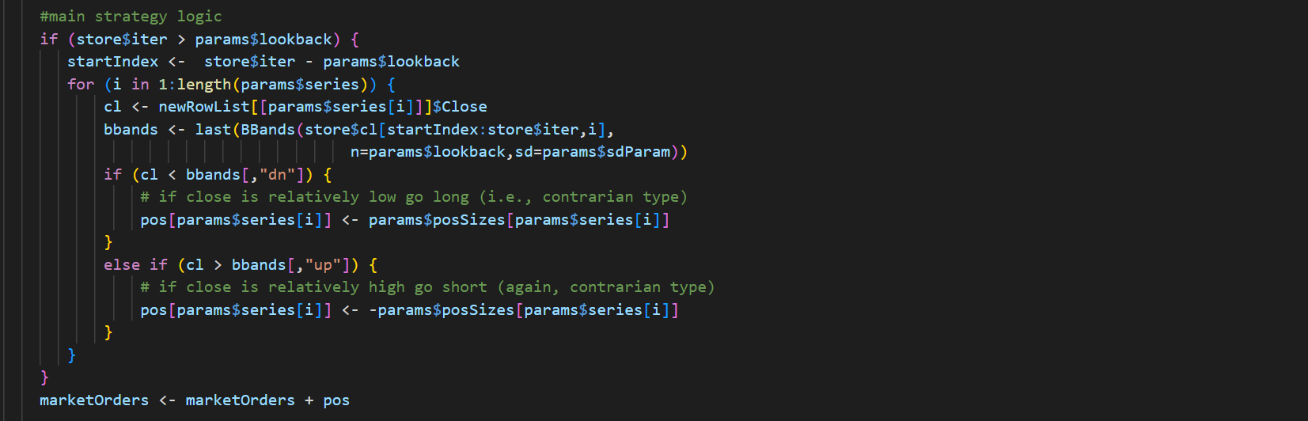

How to find an effective resistance or support level is often the key to the effective profit strategy. From the performance of the traditional bollinger bands strategy, it is not difficult to find that the strategy use the support and resistance levels itself as a threshold.

**1.2.2 Data analysis and compare**

Take Stock 1 as exampled, we plotted its K-chart observing its movements and added ATR indicators (*\*ATR represents the mean of the true fluctuation amplitude, and is a volatility indicator used to measure the price. The higher the ATR index, the greater the chance of the price trend reversal, and vice versa)*. We also plotted The Classical Decomposition Model, through this model, we can clearly display the overall trend and the fluctuation of this stock.

From which we can see that there is only a clear trend and ATR remains small numbers in stock 01. It experienced an obvious trend in prosperity and downturn in 1972, and stock price remained stable in other observation years. Following the general trend , the type of ‘fixed value’ strategy is effective and can get returns.

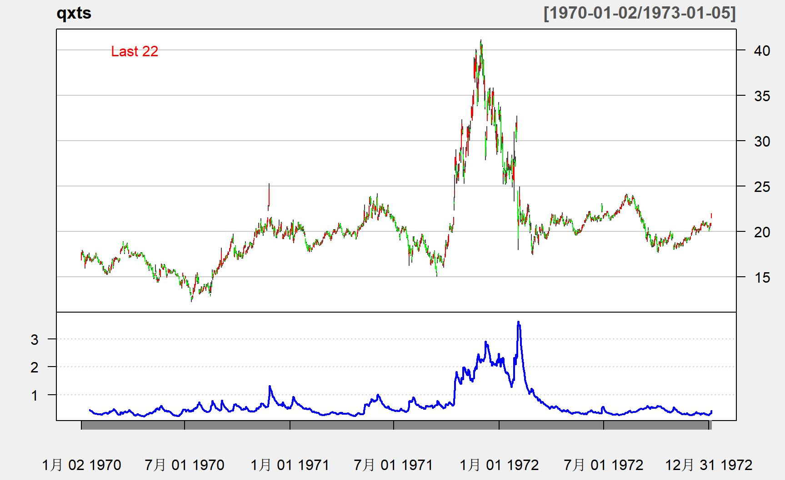

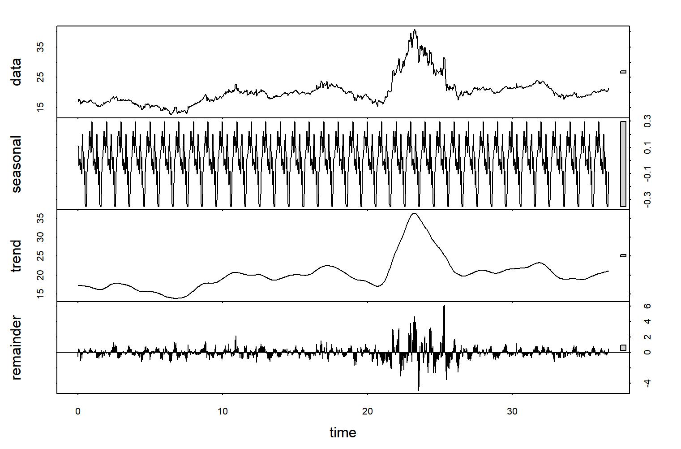

Following the general trend , the type of ‘fixed value’ strategy is effective and can get returns.

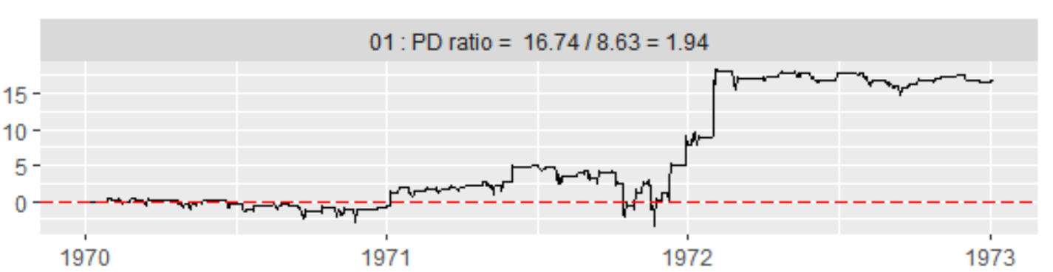

However, at the same time, its disadvantage is also very obvious: time lag. Because the middle rail of the BBands is actually a moving average, which cannot respond to multiple changes with fast and sharp trends. In uncertainty markets, using this approach means constantly switching between long and short, with little chance to generate profit. This makes it constantly losing money in the volatile market. For example, we observe at 05 stocks.

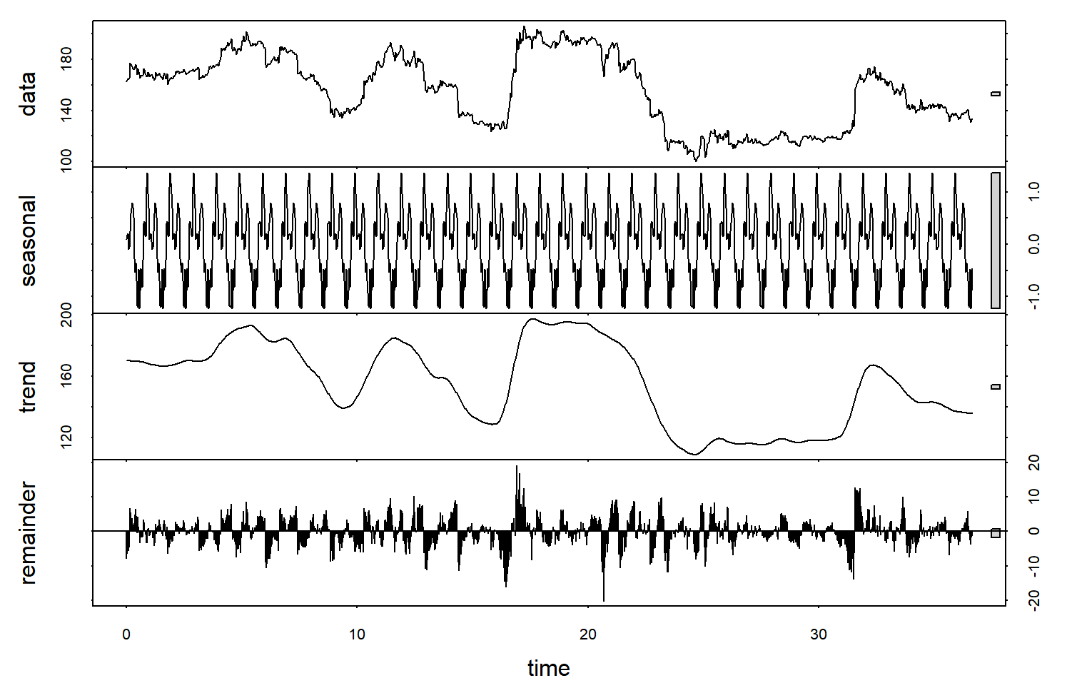

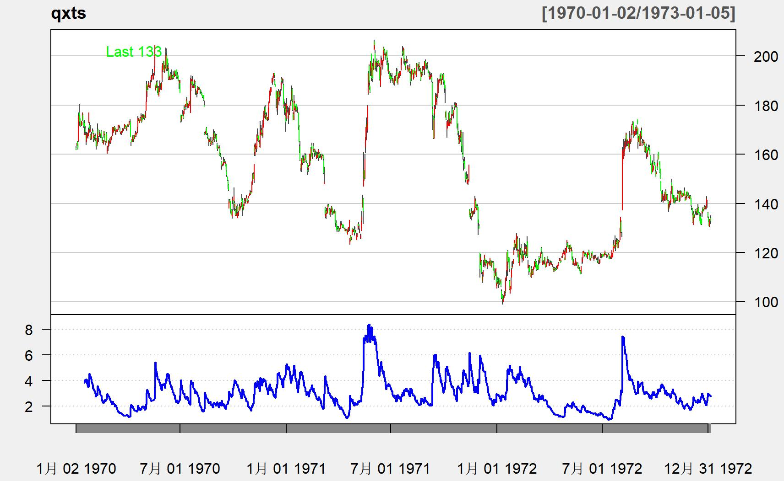

As shown in the figure, for stocks with frequently volatility and high uncertainty(05), the bollinger bands strategy is in a continuous loss state.

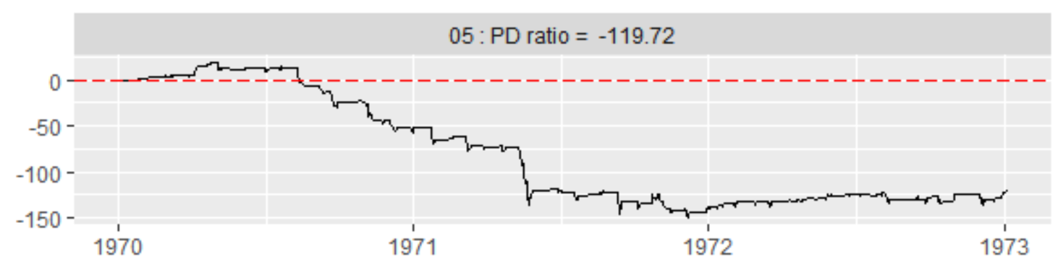

**1.3 Inspiration：Resistance Support Relative Strength (RSRS) indicator**

Thus, We consider another way of using the resistance and support levels, focusing on the relative strength between them rather than directly understanding them as the threshold of the price range. In other words, we no longer regard resistance and support as a fixed value, but as a variable, reflecting the traders' expected judgment of the top and bottom of the current market state, which can have good immediacy.

We illustrate the application logic of the relative strength of support resistance according to different market states:

1. when market is rising:

support > resistance, the bull market continues and prices accelerate rise

resistance < support, the bull market may come to an end and prices will peak

2) when market is in volatile:

support > resistance, the bull market may be about to start

resistance < support, a bear market may be about to start

3) The market is going down:

support > resistance, the bear market may be coming to an end and prices will bottom out

resistance < support, the bear market continues and prices accelerate fall

1. **RSRS strategy specify**

**2.1 Definition of RSRS and quantification of relative intensity**

Naturally, there are two questions arise:

Which data index can we use for support and resistance?

How to define and quantify their relative intensity?

After consider the given data in our project and some existing indicators, We believe that the daily highest and lowest prices are a good way to meet this demand.

Daily highs and lows can be considered as resistance and support level which recognized by the trading behavior of all market participants on that day. The daily highs and lows can quickly reflect the nature of recent market attitudes toward resistance and support levels, and that is the most important reason we use them.

The relative strength of support and resistance is described by the value of the relative position change, *delta(high)/delta(low)*, i.e., how much the high price moves for every 1 change in the low price.

*delta(high)/delta(low)* is the slope of *(low[0],high[0])* and *(low[1],high[1])*. However, the slope obtained through the two points contains too much noise due to the presence of noise in the market volume itself. Therefore, we consider building a linear regression model for the last N (low, high) data points to obtain the relative degree of change of the highest and lowest prices with high signal-to-noise ratio.

*high = alpha + beta*low + epsilon, epsilon ~ N(0,sigma) (1)*

When the slope is large, it means the support strength is stronger than the resistance strength; otherwise, it indicates the resistance strength is stronger than the support strength.

**2.2 RSRS index construction:**

Calculation of everyday slope index:

1) Take the highest price sequence and the lowest price sequence of the previous N day.

2) OLS linear regression of the two list of data(high & low) according to formula ①.

3) The fitted beta value was taken as the RSRS slope index value of that day

**2.3 The RSRS Index trading strategy:**

The trading framework adopted is threshold trading logic:

long when the RSRS exceeds a threshold S1,

short to close positions when the RSRS crosses threshold S2.

1. **Preliminary testing**
   1. **Initial parameter selection and optimization**

The beta is the slope we need. Where N can not be taken too small, otherwise it can not filter out enough noise; but also can not be too large, because we want to get is to reflect the current market support resistance relative strength, if the value is too large, the lag is too high. Here we choose N = 18.

After that, we need to determine the upper and lower thresholds. To find a more reasonable threshold value, we calculated the slope for the sample-test, and observed the historical data distribution of the slope (calculated in N=18):

|  |  |
| --- | --- |
| Mean | 0.958 |
| Standard  Deviation | 0.165 |
| Skewness | 0.167 |
| Kurtosis | 0.680 |

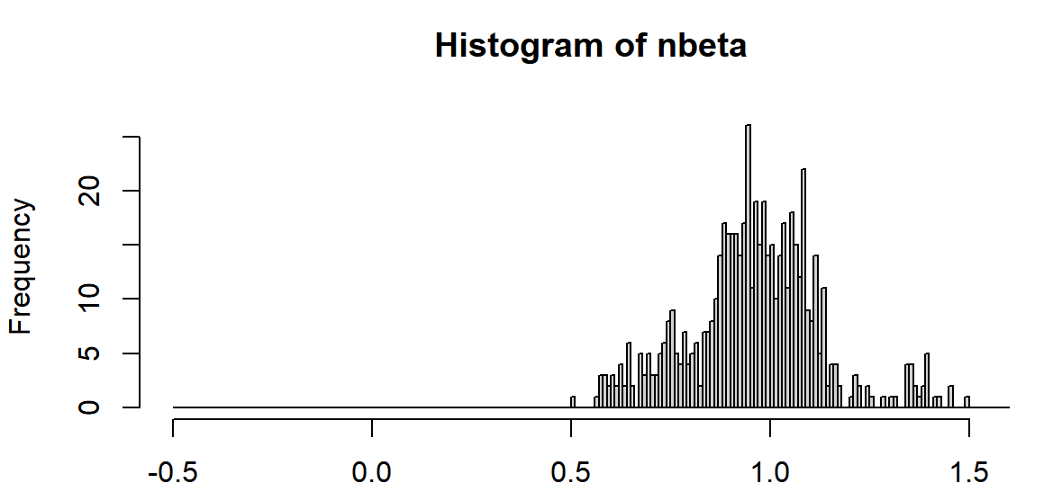

From the data, a more reasonable threshold selection is the mean plus and minus a standard deviation, we take S1=1.1 and S2=0.8.

Then, the RSRS slope trading strategy is:

1) Calculate the RSRS slope.

2) If the slope is greater than S1, long and hold.

3) If the slope is less than S2, short and close the position.

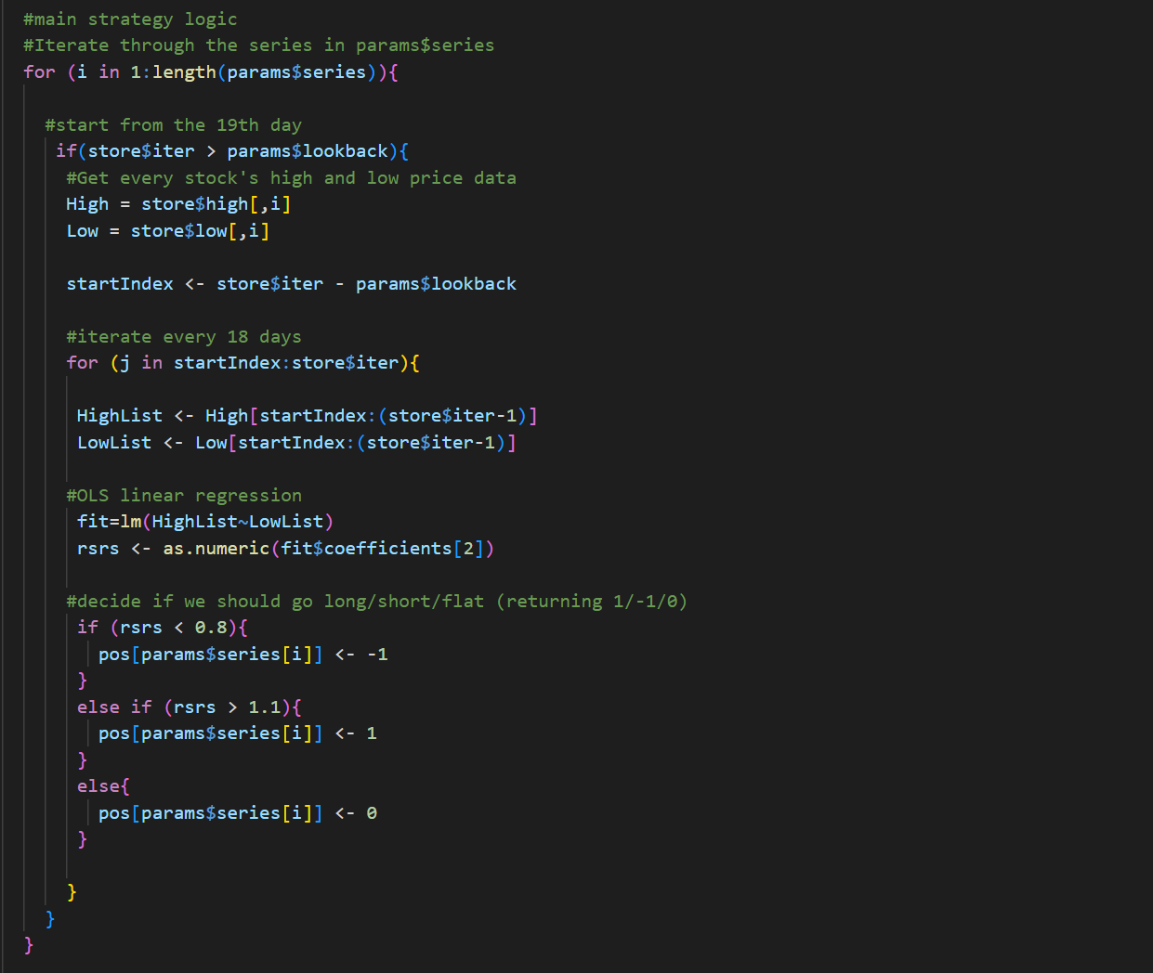

**3.2 Backtesting and results analysis**

To better test our idea, we divided the data into in-sample (1:600) data and out-sample (601-1100) data, and tested the RSRS strategy on stock 5:

**Out of-sample test**

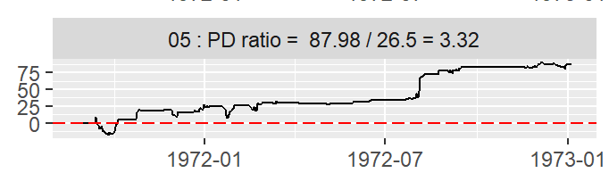

**In-sample test**

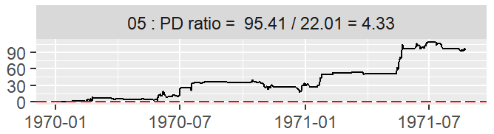

1. **Future optimization of strategy**

**4.Future Plan**

**4.1 Standard score optimization**

In the above slope threshold strategy, the upper and lower thresholds are selected with reference to the mean and standard deviation of the historical data of the slope. In practice, however, there is no guarantee that the mean and standard deviation of future data will not change as the market evolves. Traders may also be more interested in where the market is in the recent environment, or how the market will develop over the next period compared to the current one.

If we look at different periods of the market, we can see that the mean value of the slope fluctuates relatively widely. For example, if we use data from the year before the trade day (50) to calculate the mean, we can find that the mean will fluctuate between 0.6 and 1.

Therefore, it occurred to us that standardizing the RSRS would provide more flexibility to accommodate the recent overall market fundamental state. By using the RSRS standard score instead of the slope value as the indicator value, we actually increase the freedom of the strategy with the parameters M*(the period used to calculate the standard score)* and S *(the opening and closing threshold)*.

The improve of the RSRS standard score strategy is done as follows.

The slope is normalized and the standard score is taken as the indicator value.

1) take the slope time series of the previous M days. 2.

2) use this sample to calculate the standard score of the slope of the day.

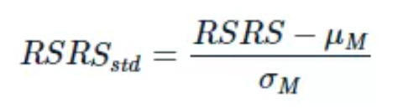

Where μM is the mean value of the slope of the previous M days, σM is the standard deviation of the previous M days, and RSRS is the indicator value of the slope of the previous N days.

3) The calculated standard score z is used as the RSRS standard score indicator value for the day.

**4.2 RSRS standard score trading strategy:**

1. Calculate the standard score based on the slope (parameter N=18,M=600).

2) If the standard score is greater than Sbuy, then buy and hold. 3.

3) if the standard score is less than Ssell, then sell and close the position.